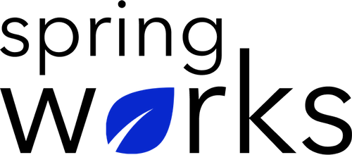
Free Template – Employee Performance Survey

Evaluate employee KPIs, identify areas for improvement

This Employee Performance Survey template is designed to enable managers and senior leaders to give actionable feedback on specific aspects of employees’ work, including areas for improvement, additional training/resources needs, and expectations of future performance. Copy this template to your Google Drive and customize it for your organization.

Communication (to be added as review instructions):

All answers you give will be treated with the utmost sensitivity, and the information will not be used for any other purpose apart from planning and improvement. Please answer this quick survey by <HOUR OF THE DAY> on <DATE>.

Demographic Information:

The following information is requested so that meaningful analysis and comparisons of group results can be made. Please check the circle corresponding to your answer.

Q: Your Department:

- Marketing
- Operations
- Tech
- Accounting
- HR

Q: Company Service:

- Under 1 Year
- 1-2 Year
- 3-5 Year
- 6-10 Year
- 10-15 Year
Employee Performance Questionnaire

To answer clearly what you think or feel about each item, please follow these steps:

- Read each item fully before you start to mark your answer.
- Pick the one answer which most nearly says what you think or how you feel.
- While completing the questions, be sure to read the special instructions which are included.

Q: Hey there. What's the name of the employee you're evaluating today?

_____________________________________________________

Q: Thanks. And how would you rate _____'s overall performance?

⭐⭐⭐⭐⭐
1 2 3 4 5

Q: How would you rate _____'s quality of work?

⭐⭐⭐⭐⭐
1 2 3 4 5

Q: This employee takes his/her job seriously.

- Strongly agree
- Agree
- Neutral
- Disagree
- Strongly disagree

Q: This employee is focused at work.

- Strongly agree
- Agree
- Neutral
- Disagree
- Strongly disagree

Q: This employee gets work done within a reasonable time frame.

- Strongly agree
- Agree
- Neutral
- Disagree
- Strongly disagree

Q: This employee has a great work ethic.

- Strongly agree
- Agree
- Neutral
- Disagree
- Strongly disagree

Q: This employee is open to new ideas and suggestions.

- Strongly agree
- Agree
- Neutral
- Disagree
- Strongly disagree

Q: This employee shows initiative to support colleagues when needed.

- Strongly agree
- Agree
- Neutral
- Disagree
- Strongly disagree

Q: What does this employee do particularly well?

Q: Where does this employee have room for improvement?

Thank you for sharing your opinions.

